**National University of Computer & Emerging Sciences, Karachi  
Spring - 2022  
Department of Computer Science  
 Assignment # 1**Fast**Due Date: 25/ Feb/ 2021**

|  |  |  |
| --- | --- | --- |
| **Course Code: CS3005** | **Course Name: Theory of Automata** | |
| **Instructor Name / Names: Musawar Ali, Bakhtawer Abbasi** | | |
| **Student Roll No:** | | **Sections: A, B, C, D, E, F** |

**Instructions**

* Submit on time, solve by yourself.
* Follow the deadlines.
* Don’t cheat and plagiarize.
* Submission method of assignment would be communicated by the course teacher.
* For any query you may contact your course teacher.

Find the regular expression and Deterministic Finite Automata for the following set of languages:

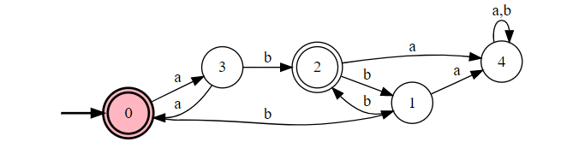

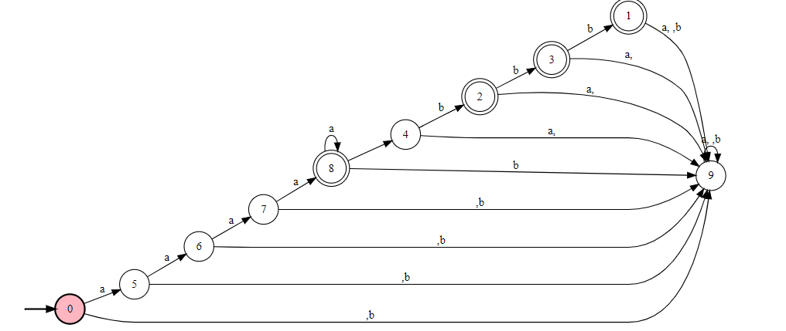

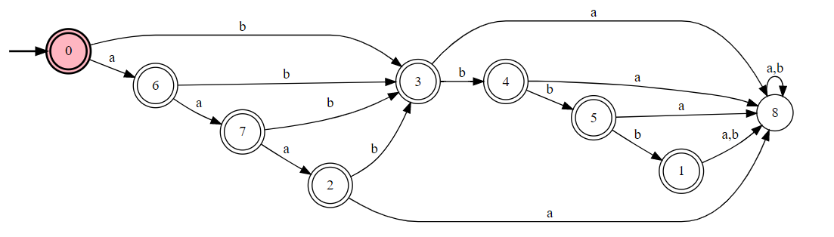

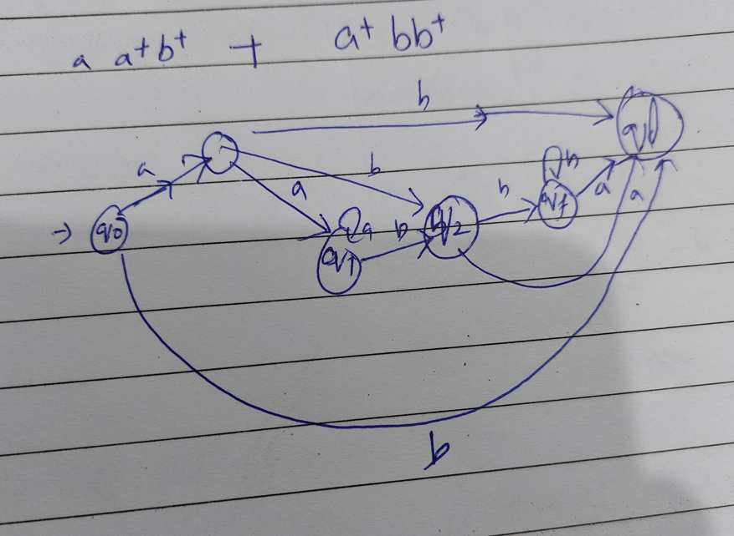

Not possible, problem is not deterministic.

But if you design solution, then it will be considered.

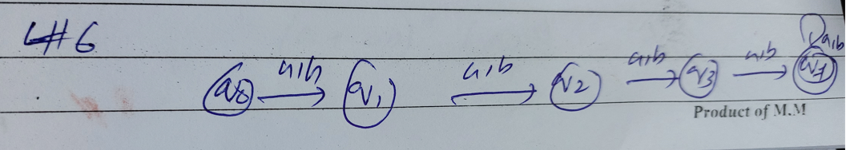

**L7** = having exactly one pair of consecutive zeros.

**1* (011*) * 00 (11*0) * 1\***

**L8** = having exactly one a.

**(b)*a(b)\***

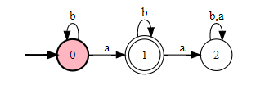

**L9** = strings containing no more than 3 a’s

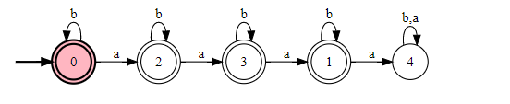

**L10** = all strings that contain at least one occurrence of each symbol in alphabet

**(a+b)*a(a+b)*b+ (a+b)*b(a+b)*a**

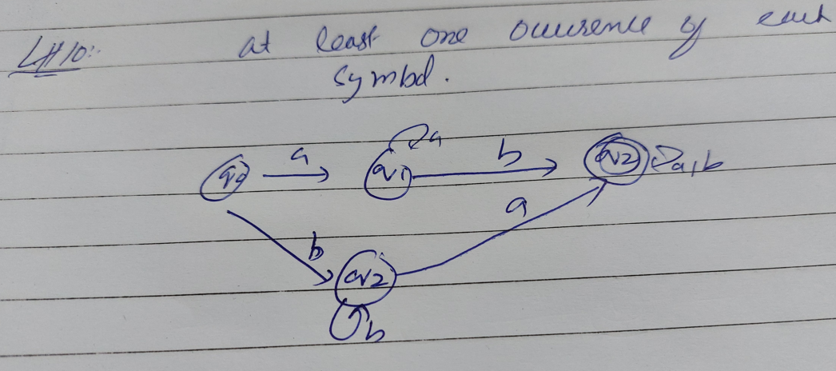

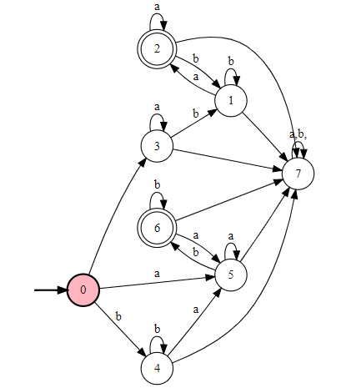

**L11** = all strings ending in 0, 1.

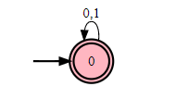

**L12** = all string not ending in 0, 1

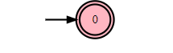

**L13** = All strings containing even number of zeros.

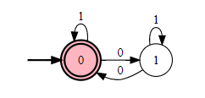

**L14** = all string having at least two occurrences of substring 00.

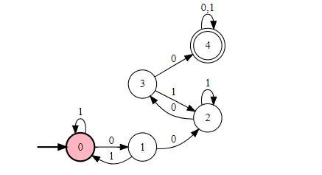

**L15** = all strings not containing 101.

**(0+10)*1\***

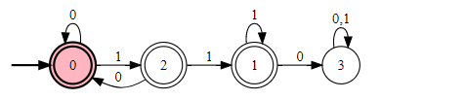

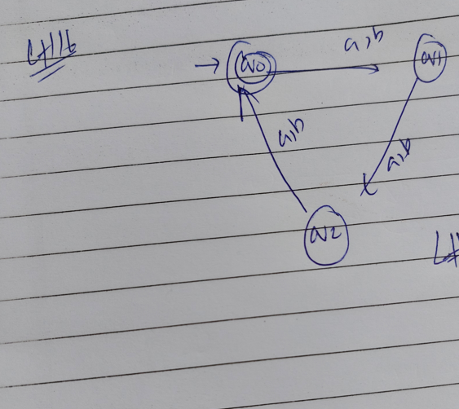

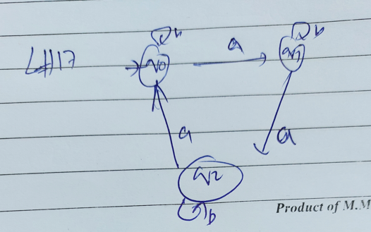

**L18** = The language of all strings containing exactly two a’s.

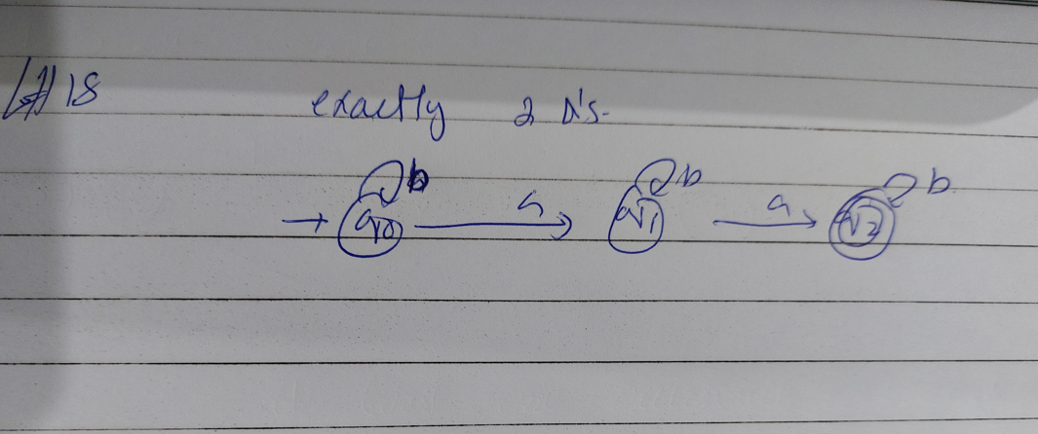

**L19** = The language of all strings containing at least two a’s.

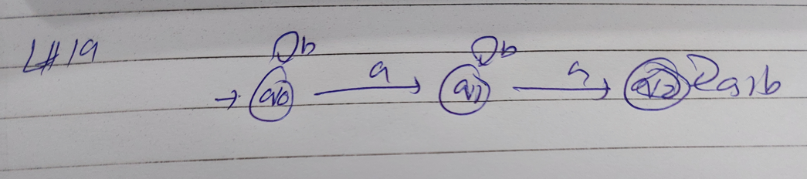

**L20** = The language of all strings that do not end with ab.

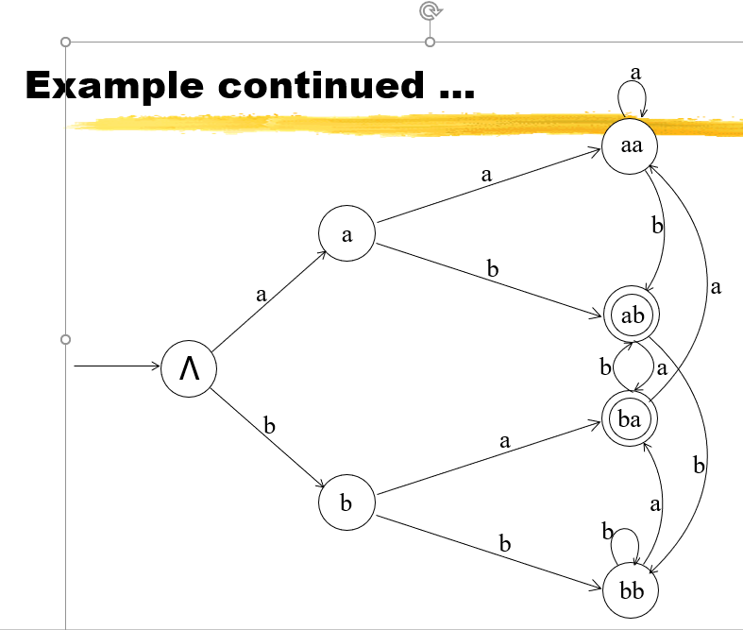

State ‘bb’ will also be final state.

**L21** = The language of all strings that begin or end with aa or bb.

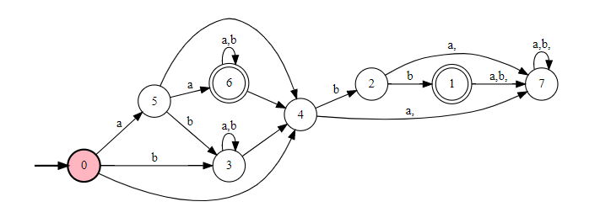

**L22** = The language of all strings not containing the substring aa.

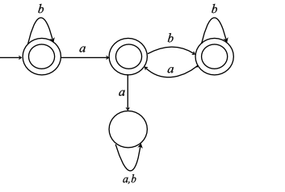

**L23** = The language of all strings in which the number of a’s is even.

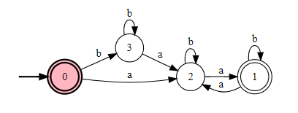

**L24** = The language of all strings in which both the number of a’s and the number of b’s are even.

**(aa+bb+(ab+ba)(aa+bb)*(ab+ba))\***

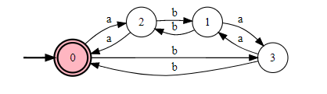

**Or**

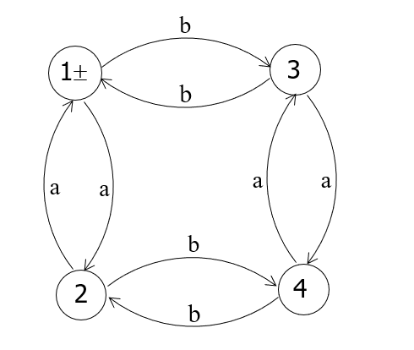

**L25** = The language of all strings containing no more than one occurrence of the string aa. (The aaa string contains two occurrences of aa.)

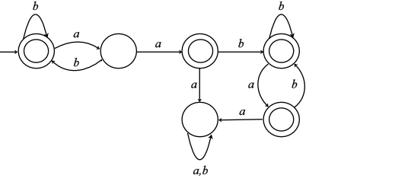

**L26** = The language of all strings in which every a (if there are any) is a followed immediately by bb.

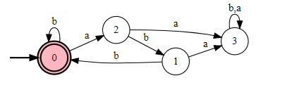

**L27** = The language of all strings containing both bb and aa as substrings.

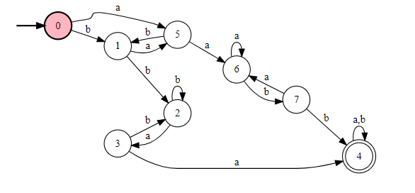

**L28** = The language of all strings containing both aba and bab as substring.

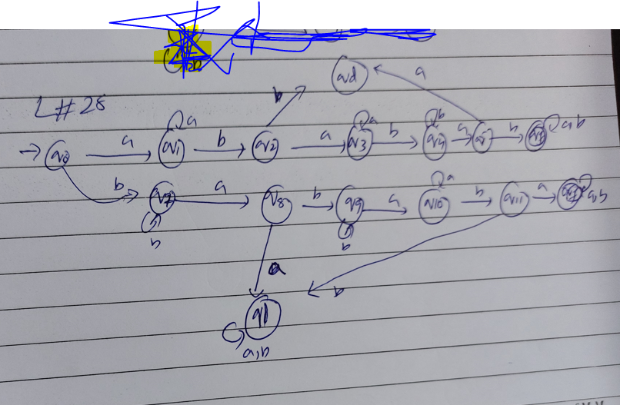

***Good Luck***